**Thessaloniki**

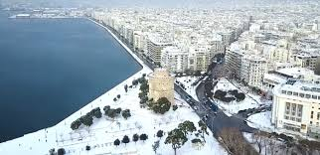

Thessaloniki is the second largest city of Greece and the most important centre of the area.

Thessaloniki is the capital city of Central Macedonia’s administrative district. Additionally, its port being the second largest commercial port of Greece and its location is close to the Balkans, between the East and the West, are important factors that contribute , both to its economic growth and its cosmopolitan characteristics.

It is a welcoming and relaxing city and it is also a city full of life, day and night (nightlife ends just before the first light of the day) due to its thousands of students studying in its universities.

Thessaloniki is easy to fall in love with – it has beauty, chaos, history and culture, a remarkable cuisine and wonderful, vast sea views.

The **White Tower** (15th century)is the hallmark of the city.

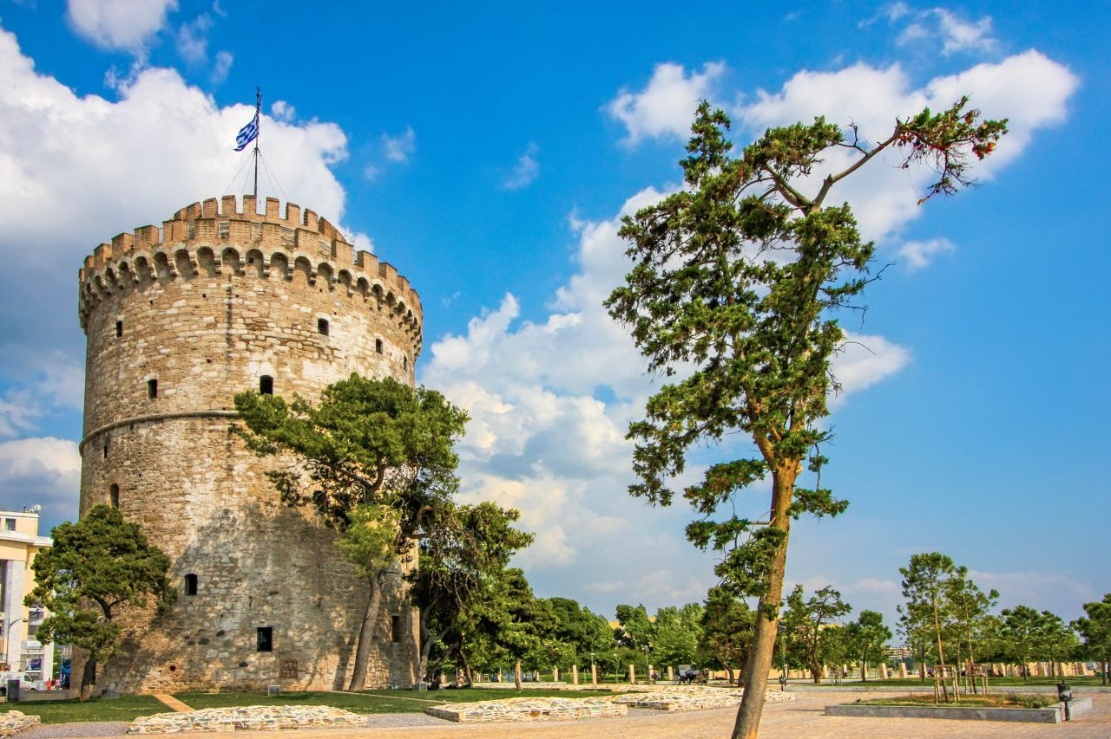

**Get in**

By plane

Thessaloniki is served by Macedonia International Airport ([IATA](https://en.wikipedia.org/wiki/IATA): SKG) for international and domestic flights. The airport is located 15 km southeast of the city. It is served by many international and regional airlines from Europe and the middle East.

By train

Regional train services within Greece (operated by TrainOSE, the Hellenic Railways Organization's train operating company), link the city with other parts of the country, from its central railway passenger station, called the "New Railway Station" located at the western end of Thessaloniki's city center.

* New Railway Station
* TrainOSE travel service

By bus

Thessaloniki is connected via the intercity KTEL bus network of Greece with every corner of country.

By car

[Athens](https://wikitravel.org/en/Athens) about 5 hr (via the A1/E75 motorway)

## Must See

### Museums and Monuments

[White Tower of Thessaloniki](https://inthessaloniki.com/item/white-tower-museum/)  
Phone : +30 2310 267 832

[Museum of Byzantine Culture](https://inthessaloniki.com/item/museum-of-byzantine-culture/)  
Address : 2 Stratou Avenue, Thessaloniki 54640, Greece  
Phone : +30 2313 306 400

[Archeological museum of Thessaloniki](https://inthessaloniki.com/item/archaelogical-museum-of-thessaloniki/)  
Address : 6 Manoli Andronikou Street, Thessaloniki, Greece  
Phone : +30 2310 830 538

[Ataturk Museum](https://inthessaloniki.com/item/ataturk-museum/)  
Address : 75, Apostolou Pavlou St, Thessaloniki, Macedonia, Greece  
Phone : +30 2310 248 452

**Discover neighbourhoods and local points in the city**

* The **Old City (Ano Polis**), in which many notable examples of Ottoman and traditional Macedonian architecture still stand, alongside humble dwellings put up by the refugees who reached Thessaloniki in droves, after the Greek defeat in Asia Minor, in 1922.
* The historical quarter of the **Ladadika**. In recent years, a series of interventions to rehabilitate the urban fabric have helped to enhance the Ladadika as a quarter for leisure pursuits.
* The **traditional markets**: the Modiano, which is housed in a rectangular building of 1922, with pedimented facade and glass roof; the Kapani or Vlalis market; Athonos Square and the ‘Louloudadika’ (literally flower market).
* **Vasilissis Olgas Avenue**, lined with many representative Neoclassical buildings and examples of late 19th century eclectic architecture.
* The central **Aristotelous Square**, surrounded by monumental buildings and open to the waterfront for a width of 100 metres.

